COIT20268

**RESPONSIVE WEB DESIGN**

**Term-1, 2020**

**Portfolio 1 & Practical Assessment-1**

**Lecturer/Tutor:**

**Tom Marotta**

**Prepared By:**

**Bishal Budhathoki**

**12116421**

**Contents**

**Chapter 1** 3

**Site Title** 3

**Developer** 3

**Rationale or focus** 3

**Planning the Site:** 3

**Content:** 3

**Target audience** 3

**Design considerations** 4

**Limiting factors** 4

**Chapter 2** 5

**Home Page:** 5

**Secondary Pages/ Product display** 6

**Secondary Pages/ Product display:** 7

**About Us page**: 8

**Business Hour Page:** 9

**Copyright Page:** 10

**Chapter 3** 11

**Mission Statement** 11

**Measure success** 11

**User Satisfaction:** 11

**Intended audience** 11

**Issues that can affect functionalities** 11

**Site Map:** 12

**Work Flow:** 12

**Chapter 4** 13

**Cascading Style Sheet** 13

**Typography** 16

**List of class names** 17

**Chapter 5** 17

**Type hierarchy** 17

**Chapter 6** 18

**Box Model**……………………………………...………………………………………………….….19

**Portfolio 1 Summarization:** 20

**Chapter 1**

**Site Title** – Flying Hobbies

**Developer** – Bishal Budhathoki

**Rationale or focus** – The website gives details to the user about the Kites, Quadcopters, Toy Planes that the Flying Hobbies has to offer. Since this website is only for the store representation and what it has to offer so, the floor plan is provided in the website. Also, Cards are provided for every item provided along with their details.

## **Planning the Site:**

**Main elements outline:**

* Homepage has welcome message
* Floor map is provided along with description for customers
* Logo representing Flying Hobbies is provided in every page
* Contact page is provided
* Business hours is displayed in separate page
* Categories are separated with card representation of the item along with their description and availability

## **Content:**

There can be 25 pages in this website. But, here 11 pages are used where only 3 product description pages is used to represent items from each 3 category. Main pages are explained:

* **Index** – Displays homepage with logo and floor plan and interactive navigation menu
* **Toy planes** – Card list of all the available Toy planes along with price, description and availability
* **Quadcopters** - Card list of all the available Quadcopters along with price, description and availability
* **Kites** - Card list of all the available Kites along with price, description and availability
* **Opening hours** – Displays business hours of Flying hobbies
* **About Us** – Displays information of Flying hobbies with their contact details
* **Copyright** – Provides copyright information
* **Product Description** – Provide details of individual product selected.

**Target audience:**

* Festival celebration – kites are used in some festivals usually in Nepalese
* Hobby people – who loves to collect items
* General public – who loves to go through toys and know how stuff works
* Kids – all the items are keener towards the kids for playing

**Design considerations:**

* **Constant Layout** – Best practice is to use similar and constant layout so that the web pages are user friendly and easy to understand.
* **Minimal Design** – Design and contents of the pages are made as minimal as possible to avoid distraction for the user/customer.
* **Standard CSS** – Recognized and standard CSS and HTML are used and validated against W3C’s validation services.
* **Standard elements easy access** – Every element in the webpages are standard and can be accessed easily.
* **Beginners Friendly** – Design are made for beginners.
* **Typography** – Font, size and style are selected that fits for this website.

**Limiting factors:**

* Browser Compatibility Issues – All browsers are not compatible with the webpage. This is best suited for Google Chrome. Issues are usually with images.

# **Chapter 2**

This section is about the layout of the Flying Hobbies website. Some of the pages including home page, content page is as follow.

## **Home Page:**

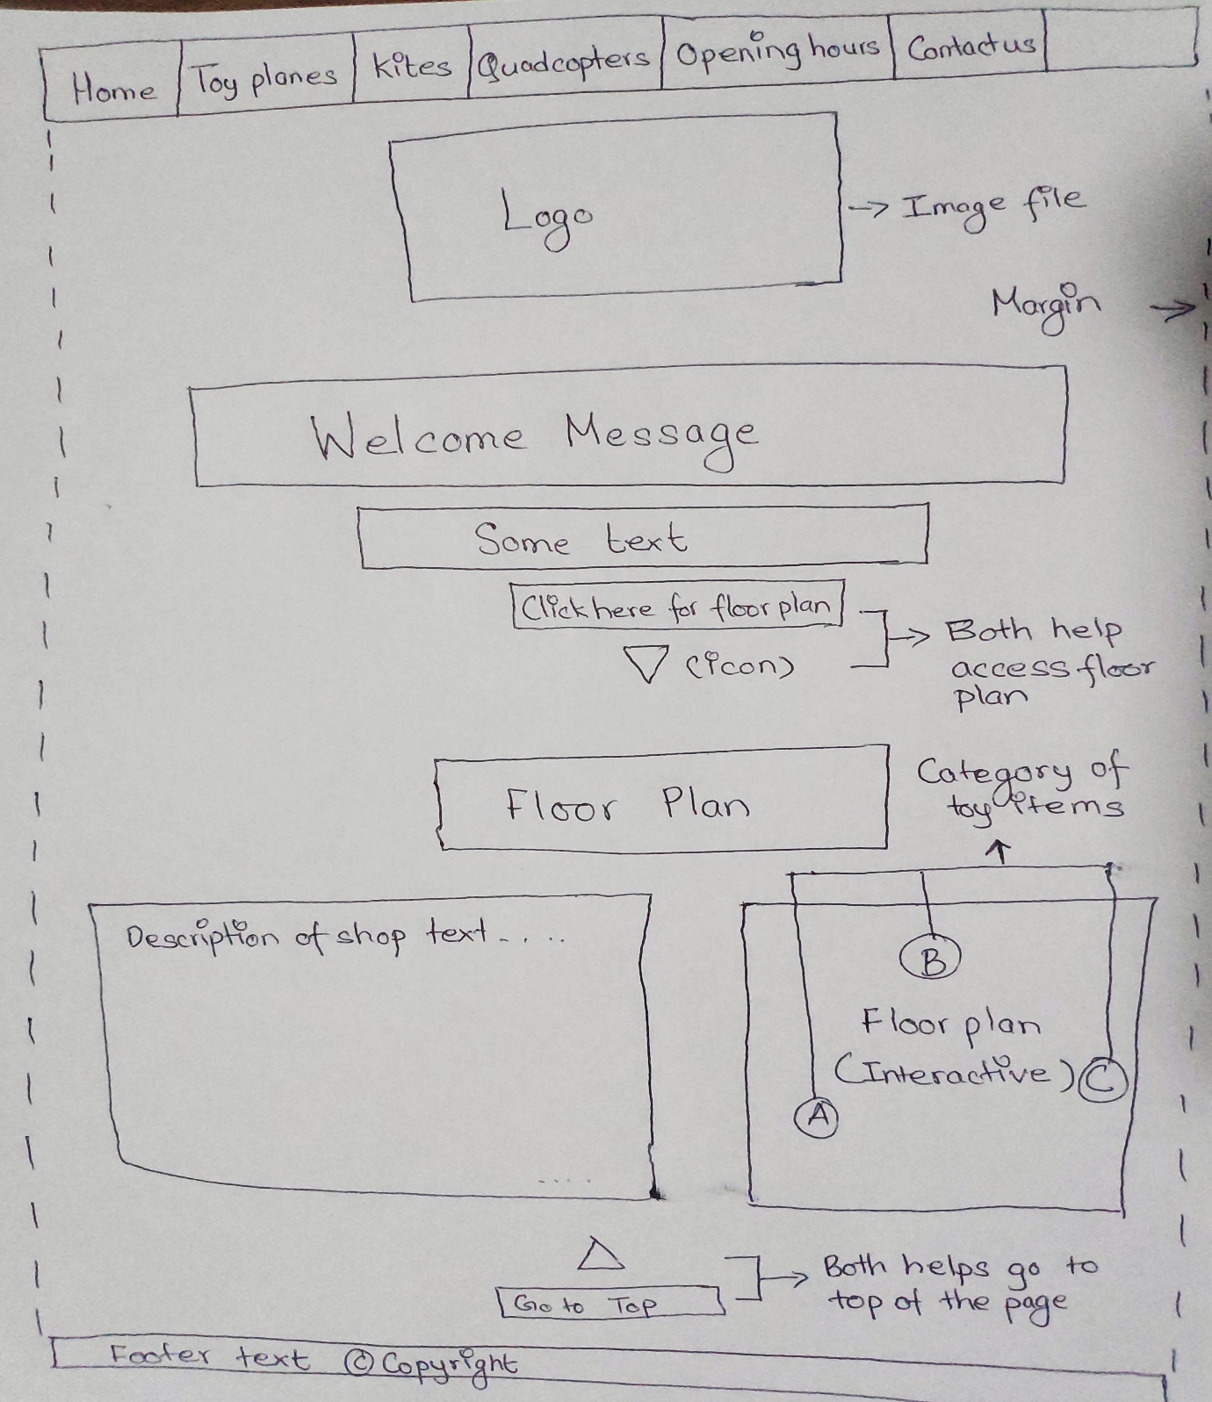

Figure 1: Home Page Layout

Home page has navigation bar at the top that links to other pages available, logo below it in the center and the welcome message. Interactive shop map is also kept below the page in right side of the screen along with the description of the side on its left. Footer is also provided with a link to copyright page.

**Secondary Pages/ Product display:**

For Toy planes, Quadcopters and Kites, all share same layout.

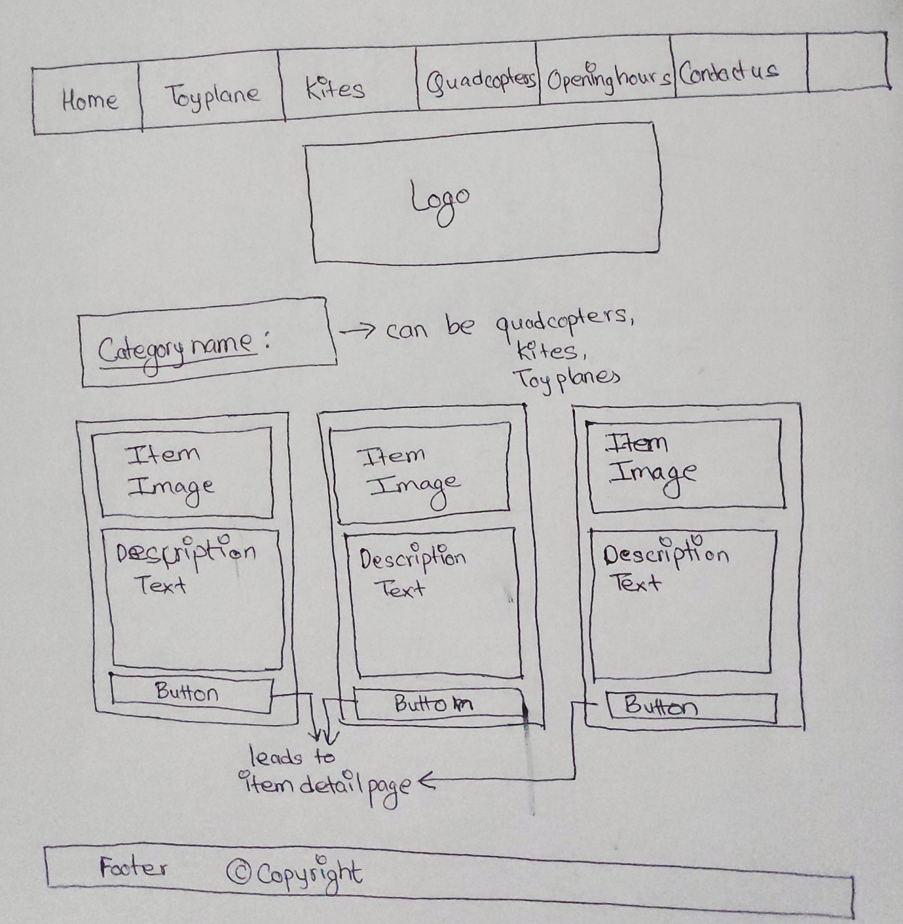

Figure 2: Product Display Page Layout

## **Secondary Pages/ Product display:**

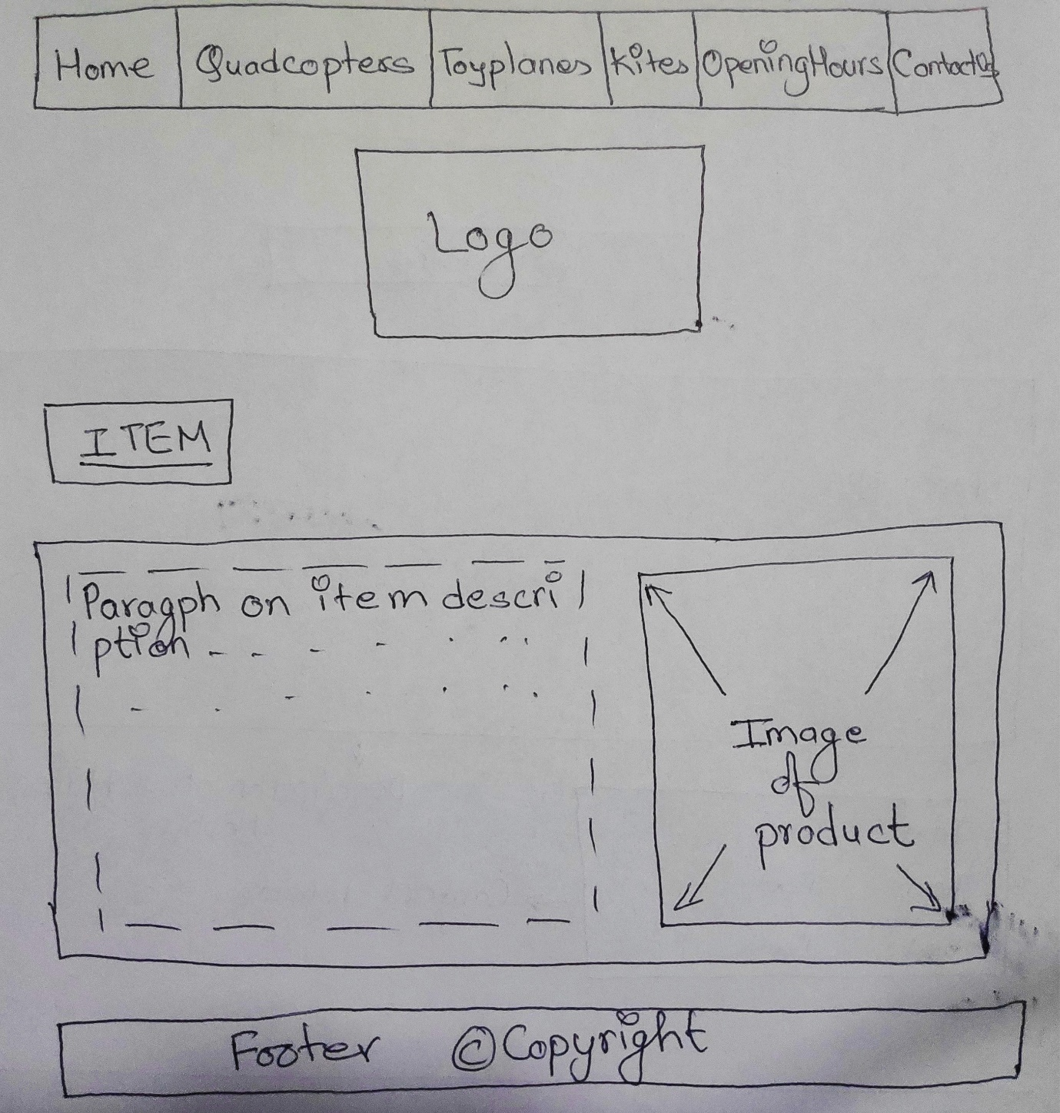

Figure 3: Individual product description Page Layout

## **About Us page**:

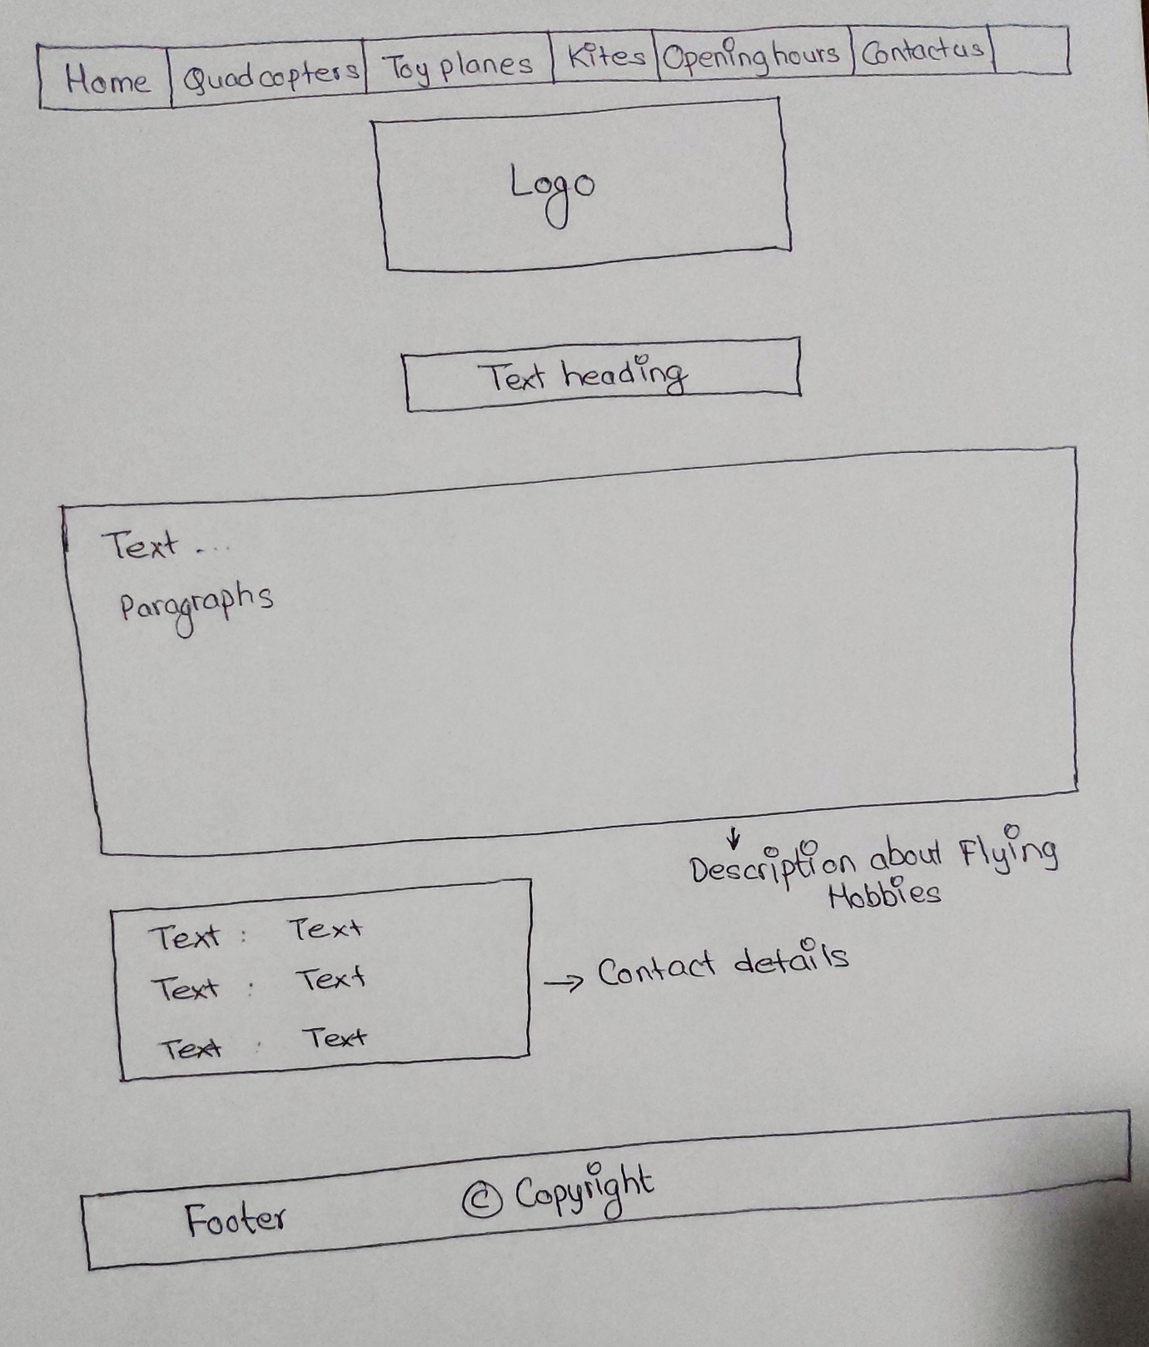

Figure 4: About Us Page Layout

## **Business Hour Page:**

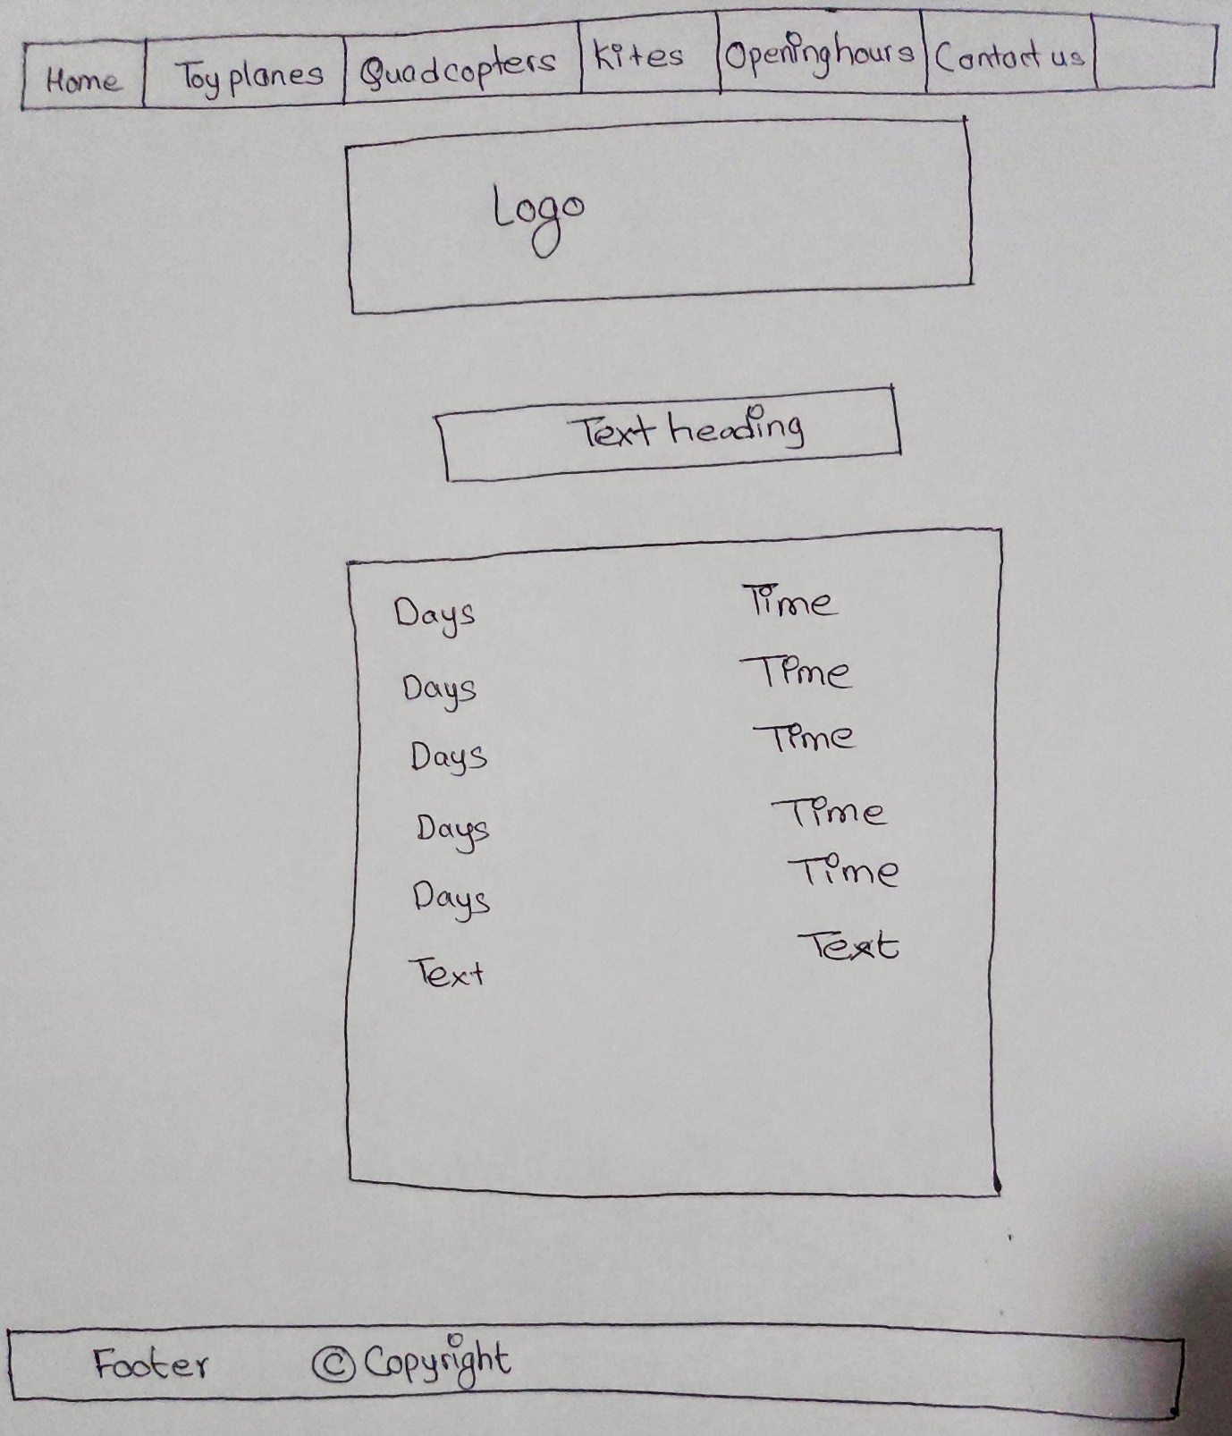

Figure 5: Business Hour Page Layout

## **Copyright Page:**

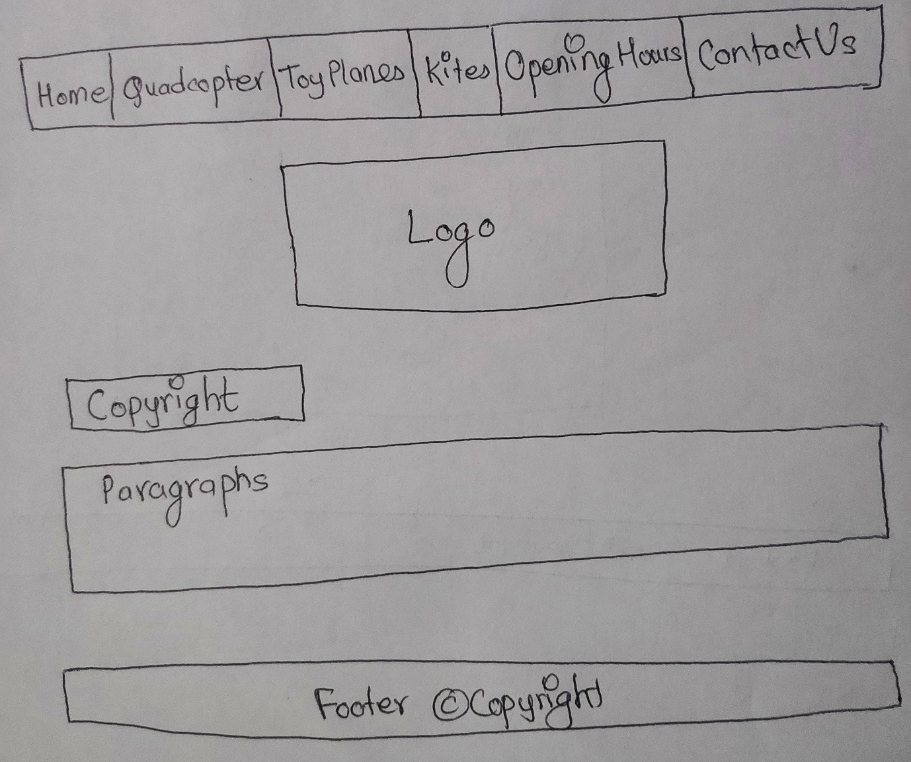

Figure 6: Copyright Page Layout

# **Chapter 3**

**Mission Statement** – Minimal & interactive web page with information on various toy planes, quadcopters and kites.

**Measure success** of the site:

* Number of customers in the shop before and after website is hosted.
* Proper feedback from the customer, managers and system admin.
* Setup user acceptance testing team

## **User Satisfaction:**

* Feedback from client and customer satisfaction.

**Intended audience:**

Intended audience are the users expected to use the website. Some of the common audiences are local people, family. Here, kids are also considered as a toy player. So, kids are intended audience that could be attracted by interactive system the website provide. Teens are also intended audience as they are also attracted with what Flying Hobbies has to offer like Kites and quadcopters. Due to the interactive layout of the website, people of all ages could be attracted.

**Issues that can affect functionalities:**

Currently, the issue faced by the website at this stage is screen compatibility. This website is best suited for 1024 * 768 to 1280*1024 size screen. Logo on a page do not resize according to screen-size. Images moves out of the card when screen size is reduced. It is working as expected in Chrome browser. Internet connection could be another issue where image loading could be slower or unable to load.

## **Site Map:**

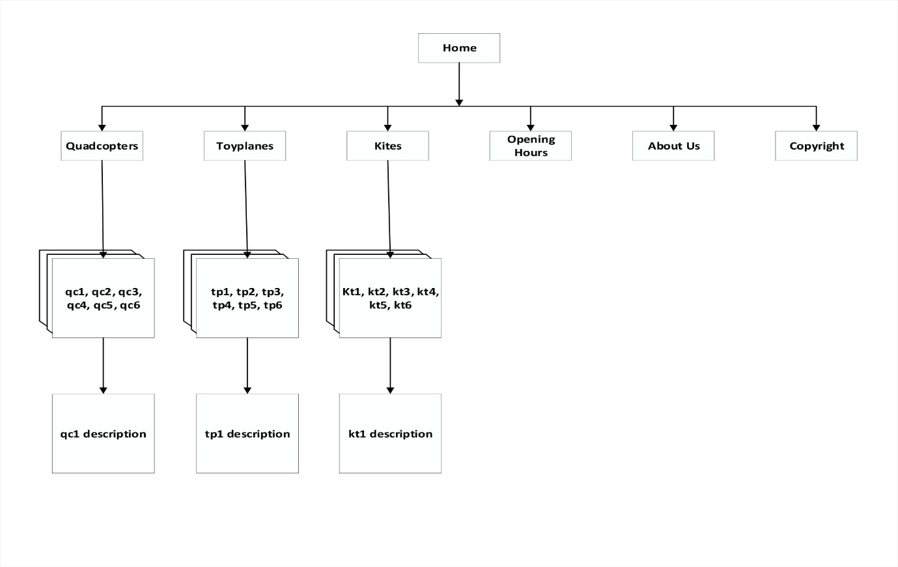

Figure 7: Flowchart of the website

This provides the page flow direction. Details are explained in below section.

## **Work Flow:**

The home page a navigation bar at the top with shop logo below it. Welcome message is provided and a text and icon to reach shop map. Sop map is an interactive map where you can reach to individual category which can also be reached from navigation bar. Shop description is left to the map. Bottom of the pages contains footer along with link to Copyright page (Copyright.html). Every web page has got navigation bar, logo and the footer. Navigation bar links to Home page (index.html), Quadcopters page (quadcopters.html), Toy plane (Toy planes.html), kites page (kites.html), About us page (aboutus.html), business hour page (openinghours.html). The shop map can be used to visit individual product page i.e. toy planes, quadcopters, kites. Every category page includes product cards. These cards when selected gives details of that product in specific in separate page. There are 6 individual description cards for every category like tp1, tp2…, tp6 for Toy plane category, qc1, qc2, …., qc6 for quadcopters and kt1, kt2, …, kt6 for Kite category.

The core structure of the Flying Hobbies website is a top navigation bar followed by brand logo, content area and a footer. Complete structure of the website is designed inside a container to ensure that the website maintains its standards even in larger screens. Website is designed by keeping white space usage minimum. By keeping every target audience in mind, website is designed. Navigating using the map is also fulfilled.

# **Chapter 4**

**Cascading Style Sheet** implementation is discussed in this section. External style sheet along with inline style sheet will be used in this website. External style sheet helps in implementation of same CSS file to multiple web pages.

We have use 2 type of CSS out of 3 and they are:

1. 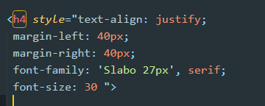Inline CSS

Figure 8: Inline CSS representation

1. External CSS

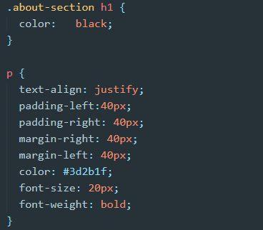 Figure 9: External CSS



Figure 10: Welcome Message

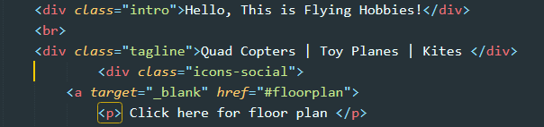

Figure 11: html for above welcome message

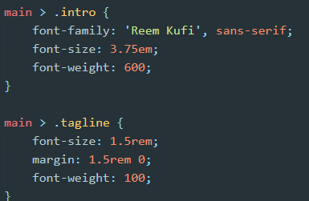

Figure 12: CSS for above welcome message



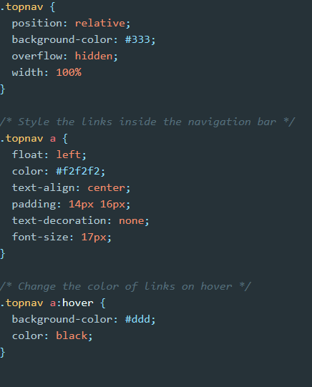 Figure 13: Navigation bar Presentation

Figure 14: Navigation bar CSS



Figure 15: Footer

Figure 16: Footer html 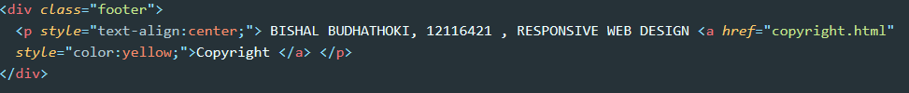

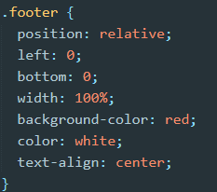

Figure 17: Footer CSS

**Typography** (font) is a crucial part in website planning. **Slabo 27px** is a font family best suited along with another alternative font for browser to render. Font size of ranging between 17px to 22px will be best suited with letter spacing of 0.45px. Font colors black, #FAFAFA and background color is #43A047. For the welcome message font-family of **Reem-Kufi** is used.

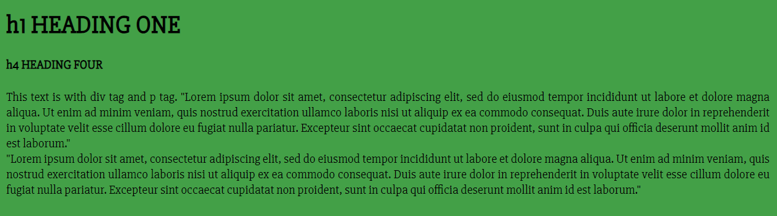

Figure 18: Used Typography Presentation



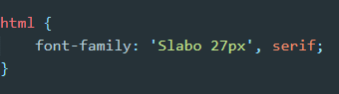

Figure 19 & 20: Used Slabo 27pxTypography Presentation



Figure 21: Used Reem-Kufi Typography Presentation

**List of class names** are:

* Wrapper - <div> which wraps entire website
* Content - <div> which wraps the content area of website
* Content-left - <div> which wraps left area of the contents
* Content-right - <div> which wraps right area of the contents
* Row - <div> which holds row content of a table
* Column - <div> which holds column content of a table
* Card - <div> which hold content of card area

# **Chapter 5**

**Type hierarchy** for the website is discussed in this chapter. A mockup page has been created (mockup.html) to reveal it. It is not linked to any pages. Screenshot is attached below.

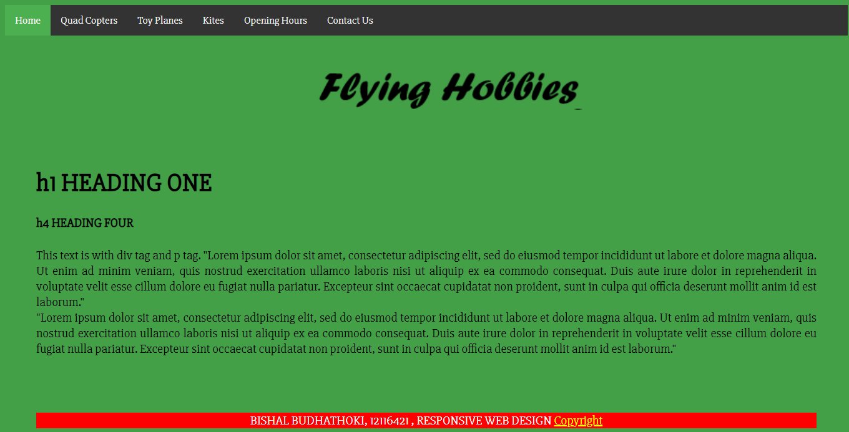

Figure 22: Mockup.html page representation

Here, h1 and h4 are the heading level used. Letter spacing of 0.45px is used for readability of the web pages. Line height is normal. Custom hyperlinks are used where needed in website. Navigation bar has its separate color, line height and text style. Hover over the navigation bar and buttons where available will change its background color. Any other available links are also styled in various way.



Figure 23: Fonts used from external source

# **Chapter 6**

For the **visual formatting models, box model** is used. Here, 3 kind of box model are used

* “display: inline-block;”
* “display: table;”
* “display: block;”

Item display card uses “display: table”, business hours display uses inline block and cards images and content uses block. All the panels and cards are given proper margin, padding and border property along with the shadow property.

Below is some representation of pages with and without Box Model usage.

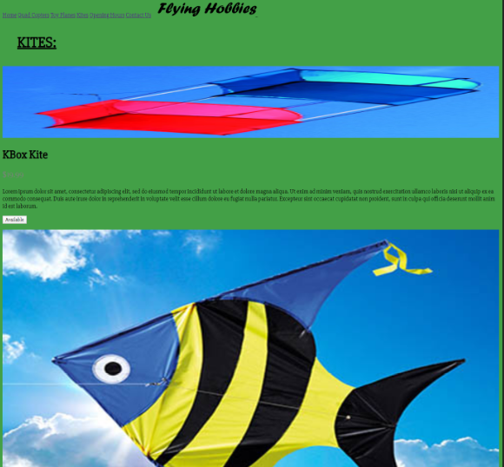

Figure 24: No box model in Product list page

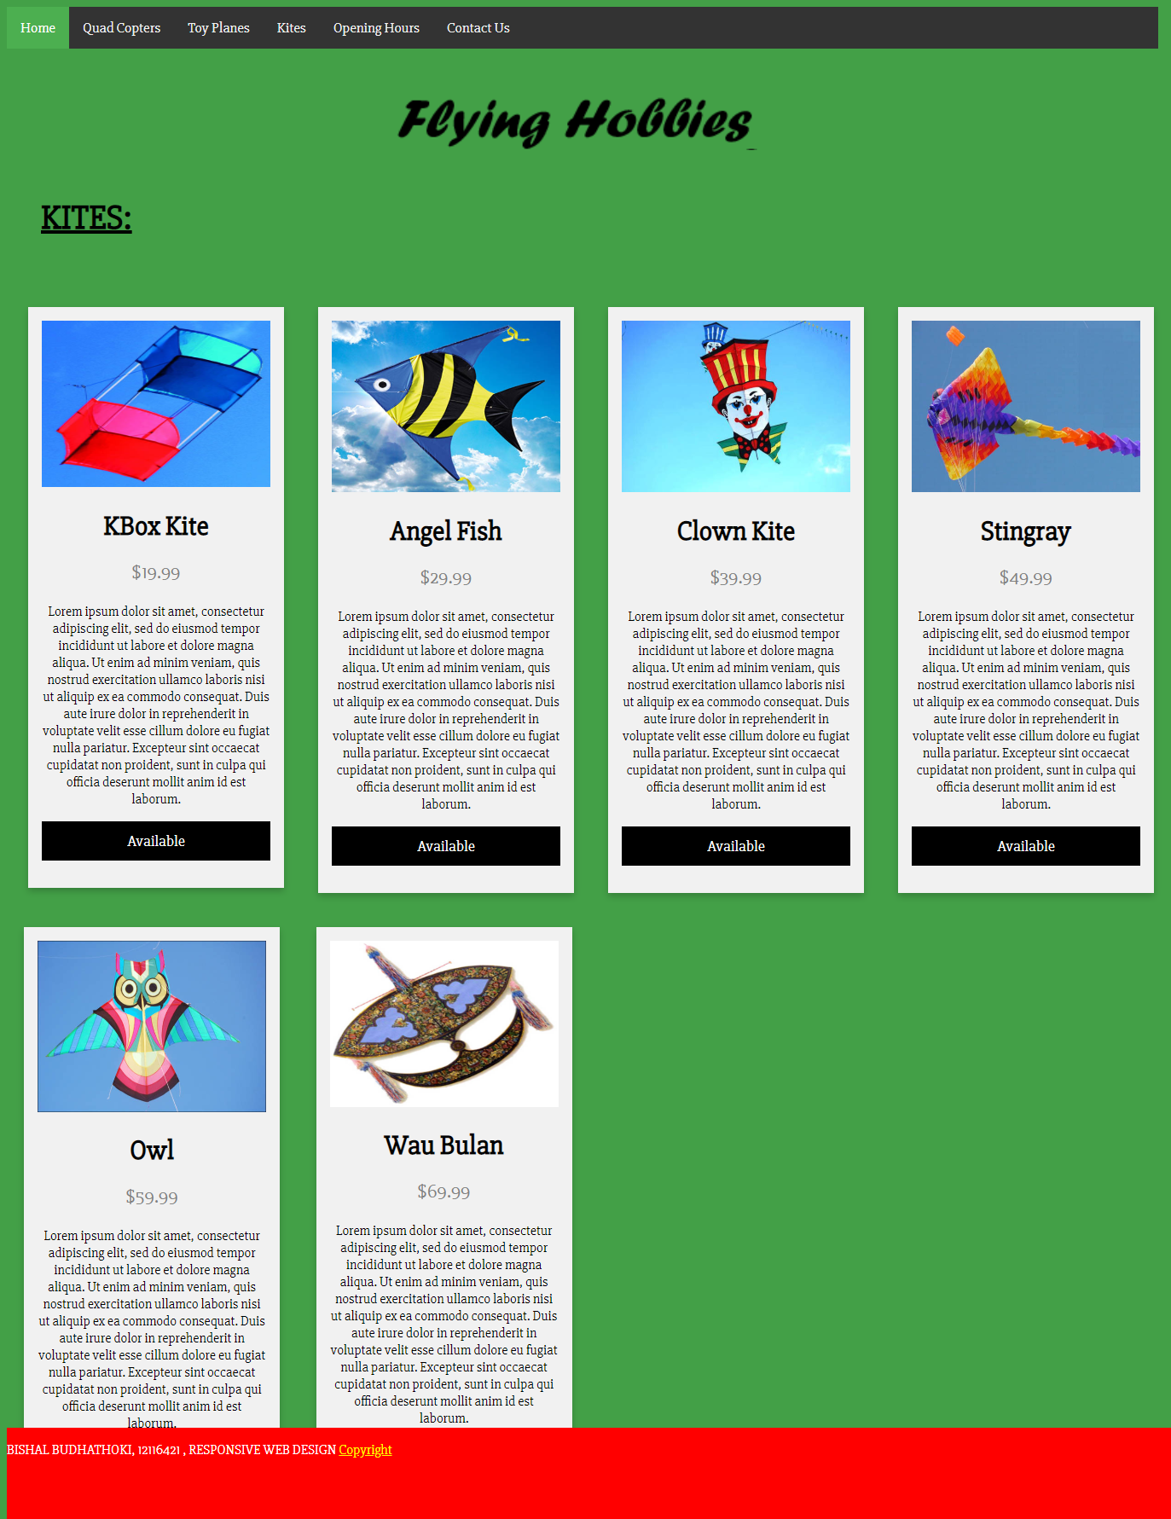

Figure 25: With Box model for the same page.

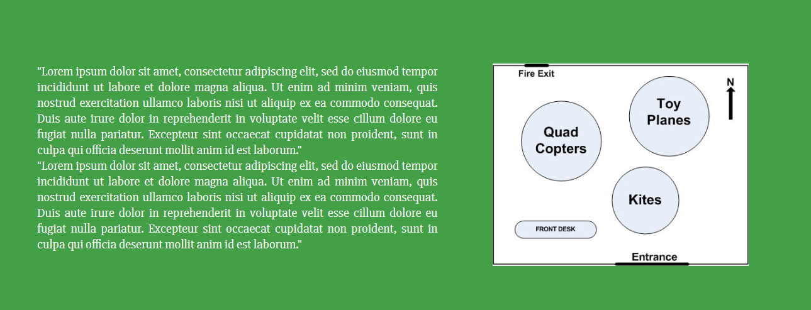

Figure 26: With Box Model

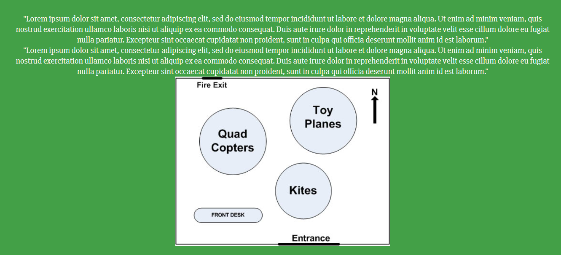

Figure 27: Without Box Model

# **Portfolio 1 Summarization:**

Here, when the customer visits the website they are presented with the welcome message. Then they can view the floor plan to make up the mind on store map. There are 3 category of items and each item has its own production description page. With that, business hours to know which time and what day of the week the store is open. Customer can also use the Contact Us page to contact store if necessary.

Latest HTML5 and CSS3 is used to develop the website with easy navigation in mind. Every web page is connected with each other as needed. Each page is user friendly and also supports Chrome browser with screen size ranging from 1024 * 768 and 1280 * 1024 pixels.